**THIS VERSION IS NOW DEFUNCT. Leaving here or reference, but please don’t comment on it. The current version is now on GitHub. Please ask for a copy if you want to see the latest.**

**IMPORTANT: we’re writing this in R Markdown on GitHub (https://github.com/EcoClimLab/growth_phenology), and the master lives there, so be sure to make all changes in suggestion mode (otherwise we won’t capture them).**

**If you have a GitHub account and need access to the repo (<https://github.com/EcoClimLab/growth_phenology>), please let me know. You’re more than welcome to open or comment on issues there (some hyperlinked in the text).**

**Please focus on the content/ methods/ organization. We’re not yet at the word-smithing stage.**

**~~~~**

**Title:** Warmer spring temperatures in temperate deciduous forests advance the timing of tree growth but have little effect on annual woody productivity */annual increments*

**Authors:**

Cameron Dow1

Albert Y. Kim1,2

Loïc D’Orangeville3,4

Erika B. Gonzalez-Akre1

Ryan Helcoski1

Valentine Herrmann1

Grant L. Harley5

Justin T. Maxwell6

Ian McGregor1,7

William McShea1

Sean McMahon8,10

David A. Orwig3

Neil Pederson3

Alan J. Tepley1,9

Kristina J. Anderson-Teixeira1,10*

**Author Affiliations:**

1. Conservation Ecology Center; Smithsonian Conservation Biology Institute; Front Royal, VA 22630, USA
2. Statistical & Data Sciences; Smith College; Northampton, MA 01063, USA
3. Harvard Forest, Petersham, MA 01366, USA
4. Faculty of Forestry and Environmental Management, University of New Brunswick, Fredericton, NB, E3B 5A3, Canada.
5. Department of Geography & Geological Sciences, University of Idaho, ID 83844, USA
6. Department of Geography, Indiana University, Bloomington, IN, 47405, USA
7. Center for Geospatial Analytics; North Carolina State University; Raleigh, NC 27607, USA
8. Smithsonian Environmental Research Center, Edgewater, MD, USA
9. Canadian Forest Service, Northern Forestry Centre, Edmonton, Alberta, Canada
10. Forest Global Earth Observatory; Smithsonian Tropical Research Institute; Panama, Republic of Panama

*corresponding author: [teixeirak@si.edu](mailto:teixeirak@si.edu); +1 540 635 6546

*NOTE: In general, this needs to be condensed. The typical length of an article with 3-4 modest display items (figures and tables) is 2000-2500 words (summary paragraph plus body text). We’re currently at ~2700 words (or ~3000 with fig captions) and 2 modest + 2 large display items. Articles typically have 30-50 references (currently ok there)*

# 1 (Summary paragraph)

(*word limit 200 - this is currently way too long.*)

As the climate changes, warmer spring temperatures are causing earlier leaf-out1,2 and commencement of net carbon dioxide (CO2) sequestration2 in temperate deciduous forests, resulting in longer growing seasons1,3–5 and increased annual CO2 sequestration2,6–10. However, less is known about how spring temperatures affect tree stem growth, which consumes a modest portion of the carbon fixed annually11 but sequesters that carbon in wood that has a long residence time in the ecosystem12,13 or as wood products14. Here, we show that in two temperate deciduous forests, warmer maximum spring temperatures consistently shifted woody growth milestones earlier but had mixed, weak effects on peak growing season length, maximum daily growth rates, and annual growth. The latter finding is confirmed on the centennial scale by 207 tree-ring chronologies from 114 forests across eastern North America, which show that annual growth is by far more sensitive to temperatures during the peak growing season than in the spring. These findings align with findings that annual CO2 sequestration is more strongly linked to conditions in the peak growing season than to growing season length10, with observations that warm springs result in earlier leaf senescence15,16, and with evidence that forest CO2 sequestration is sink-limited16. They contrast, however, with the expectation *in most models16* that an earlier start to growing season would significantly increase the rate of biomass accumulation and thereby enhance the CO2 sink of temperate deciduous forests. Rather, our findings imply that *the extra CO2 sequestered in years with warmer springs6–8 is not allocated to the long-lived woody biomass C pool and is therefore unlikely to have a lasting impact on the forest C balance.* Thus, warming spring temperatures are unlikely to increase the woody productivity or strengthen the carbon sink of temperate deciduous forests.

*The introduction and summary paragraph need work, and removal of overlap. Organizational/content suggestions are welcome, but we’re not at the stage of word-smithing.*

***(DROP THIS FIRST PARAGRAPH?)*** As Earth’s atmospheric CO2 concentrations and temperatures increase, the responses and feedbacks of forests will play an important yet uncertain role in influencing atmospheric CO2 and climate change17,18. Temperate deciduous forests, including those in eastern North America, *(have been net carbon sinks over the past several decades)*… *[Discuss this sink, mechanisms, uncertainties, ending with the point that one meaningful uncertainty is how the C sink will respond to warming springs]*

In recent decades, warming temperatures have resulted in widespread phenological changes indicative of earlier arrival of spring20 and sometimes later autumn senesence1. In temperate deciduous forests, spring leaf-out has been occurring earlier1, as has the beginning of the annual period of net CO2 sequestration2. Warmer spring temperatures and earlier leaf-out are also linked to earlier leaf senescence15,21, apparently because of sink-limitation to CO2 sequestration16. However, warmer summer and autumn temperatures can delay leaf senescence1,5,7,8,15,22, and as a result warming may advance or delay autumn senescence [REFS]. The net result is that spring warming generally results in an increased growing season length, measured as the period over which trees have leaves1,1,3–5 and the ecosystem is a net CO2 sink[REFS]. The expectation, is that as growing season length increases, net annual carbon sequestered will increase as well (*i,e*, net ecosystem exchange, )2,9,10,23, and [this expectation is represented in models](https://github.com/EcoClimLab/growth_phenology/issues/56).16 However, recent evidence that leaf senescence is induced when the seasonal carbon-sink capacities of trees are reached suggests that warmer spring temperatures and earlier leaf-out could advance autumn senescence and *will not necessarily lead to drastically increased C sequestration*16.

We know very little about how the longest-lived component of fixed carbon, the woody growth of trees, is responding to warming spring temperatures. In fact, we know little about the stem-growth phenology of temperate deciduous species, with multi-year records of growth phenology having been published for only one site.**doranngeville_radial_inreview?** *(We need to make sure we’re not missing anything.)* Tree-ring records, which can be used to examine correlations of annual growth to monthly temperatures but not to understand growth phenology, reveal that growth of temperate deciduous trees tends to be most sensitive to summer temperatures (REFS), with some hints that warmer springs may have a modest positive effect on growth (e.g., Refs.24 [MORE]). Thus, tree-ring records do not necessarily support the suggestion that warming spring temperatures would increase annual CO2 sequestration. Characterizing phenological responses of stem growth to warming spring temperatures is critical to bridging this conceptual disconnect and understanding how forest biomass growth is likely to change as the climate warms.

Here, we characterize how early spring temperatures affect stem growth phenology, growth rates, and annual growth of temperate deciduous trees in two forests and annual growth across forests spanning eastern North America.

## Dendrometer band analysis

First, using dendrometer band measurements taken throughout the growing season at the Smithsonian Conservation Biology Institute (SCBI; Virginia; n = **146** trees over 10 years) and Harvard Forest (Massachusetts; n = **755** trees over six years), we fit a growth model25 to determine the days of year where 25, 50, and 75% annual growth was achieved (, , ), peak growing season length (-), maximum growth rates () and the DOY on which they occurred (), and total annual growth (; Fig. 1). This analysis was performed separately for ring- and diffuse-porous species, which differ in growth phenology**doranngeville_radial_inreview?**, and set in the context of leaf phenology at these sites.

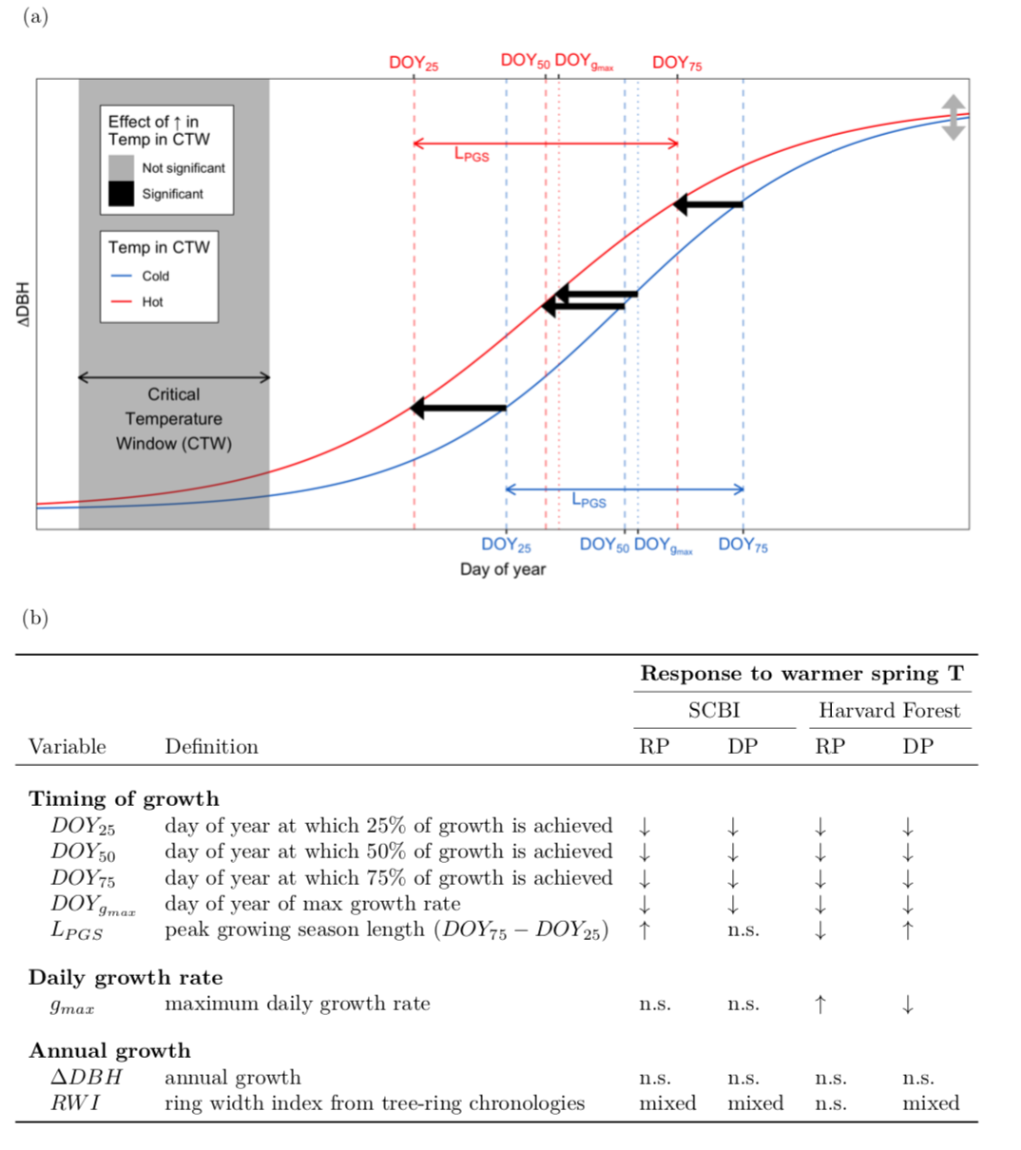

***Figure 1 | Summary of tree growth changes under warmer spring temperatures.*** *(a) Schematic illustrating parameters of interest and summarizing how each responds to warmer maximum temperatures during a ‘critical temperature window’, defined as that with the strongest control over ; (b) Variable definitions and summary responses to warmer spring temperatures at two temperate forests and for two groups of broadleaf deciduous species (RP=ring porous; DP=diffuse porous), where up and down arrows indicate increases and decreases, respectively, ‘n.s.’ indicates no signficant correlation, and ‘mixed’ indicates a mix of signficant and non-signficant correlations, often in different directions.*

Both leaf phenology and stem growth milestones occurred earlier at SCBI than at Harvard Forest, with stem growth milestones achieved on average 6-10 days earlier at SCBI (Fig. 2, Extended Data Table 2). Consistent with the results of Ref**doranngeville_radial_inreview?**, ring-porous species began growing earlier, reaching the benchmark earlier (by 31 days at SCBI and 32 at Harvard Forest), and their growth was spread out over a longer growing season (average 21 and 19 days longer at SCBI and Harvard Forest, respectively; Fig. 2, Extended Data Figure 2, Extended Data Table 2). Growing season length was similar across sites, with being, on average, only two days longer at SCBI for ring-porous species and less than one day longer for diffuse-porous species (Extended Data Table 2).

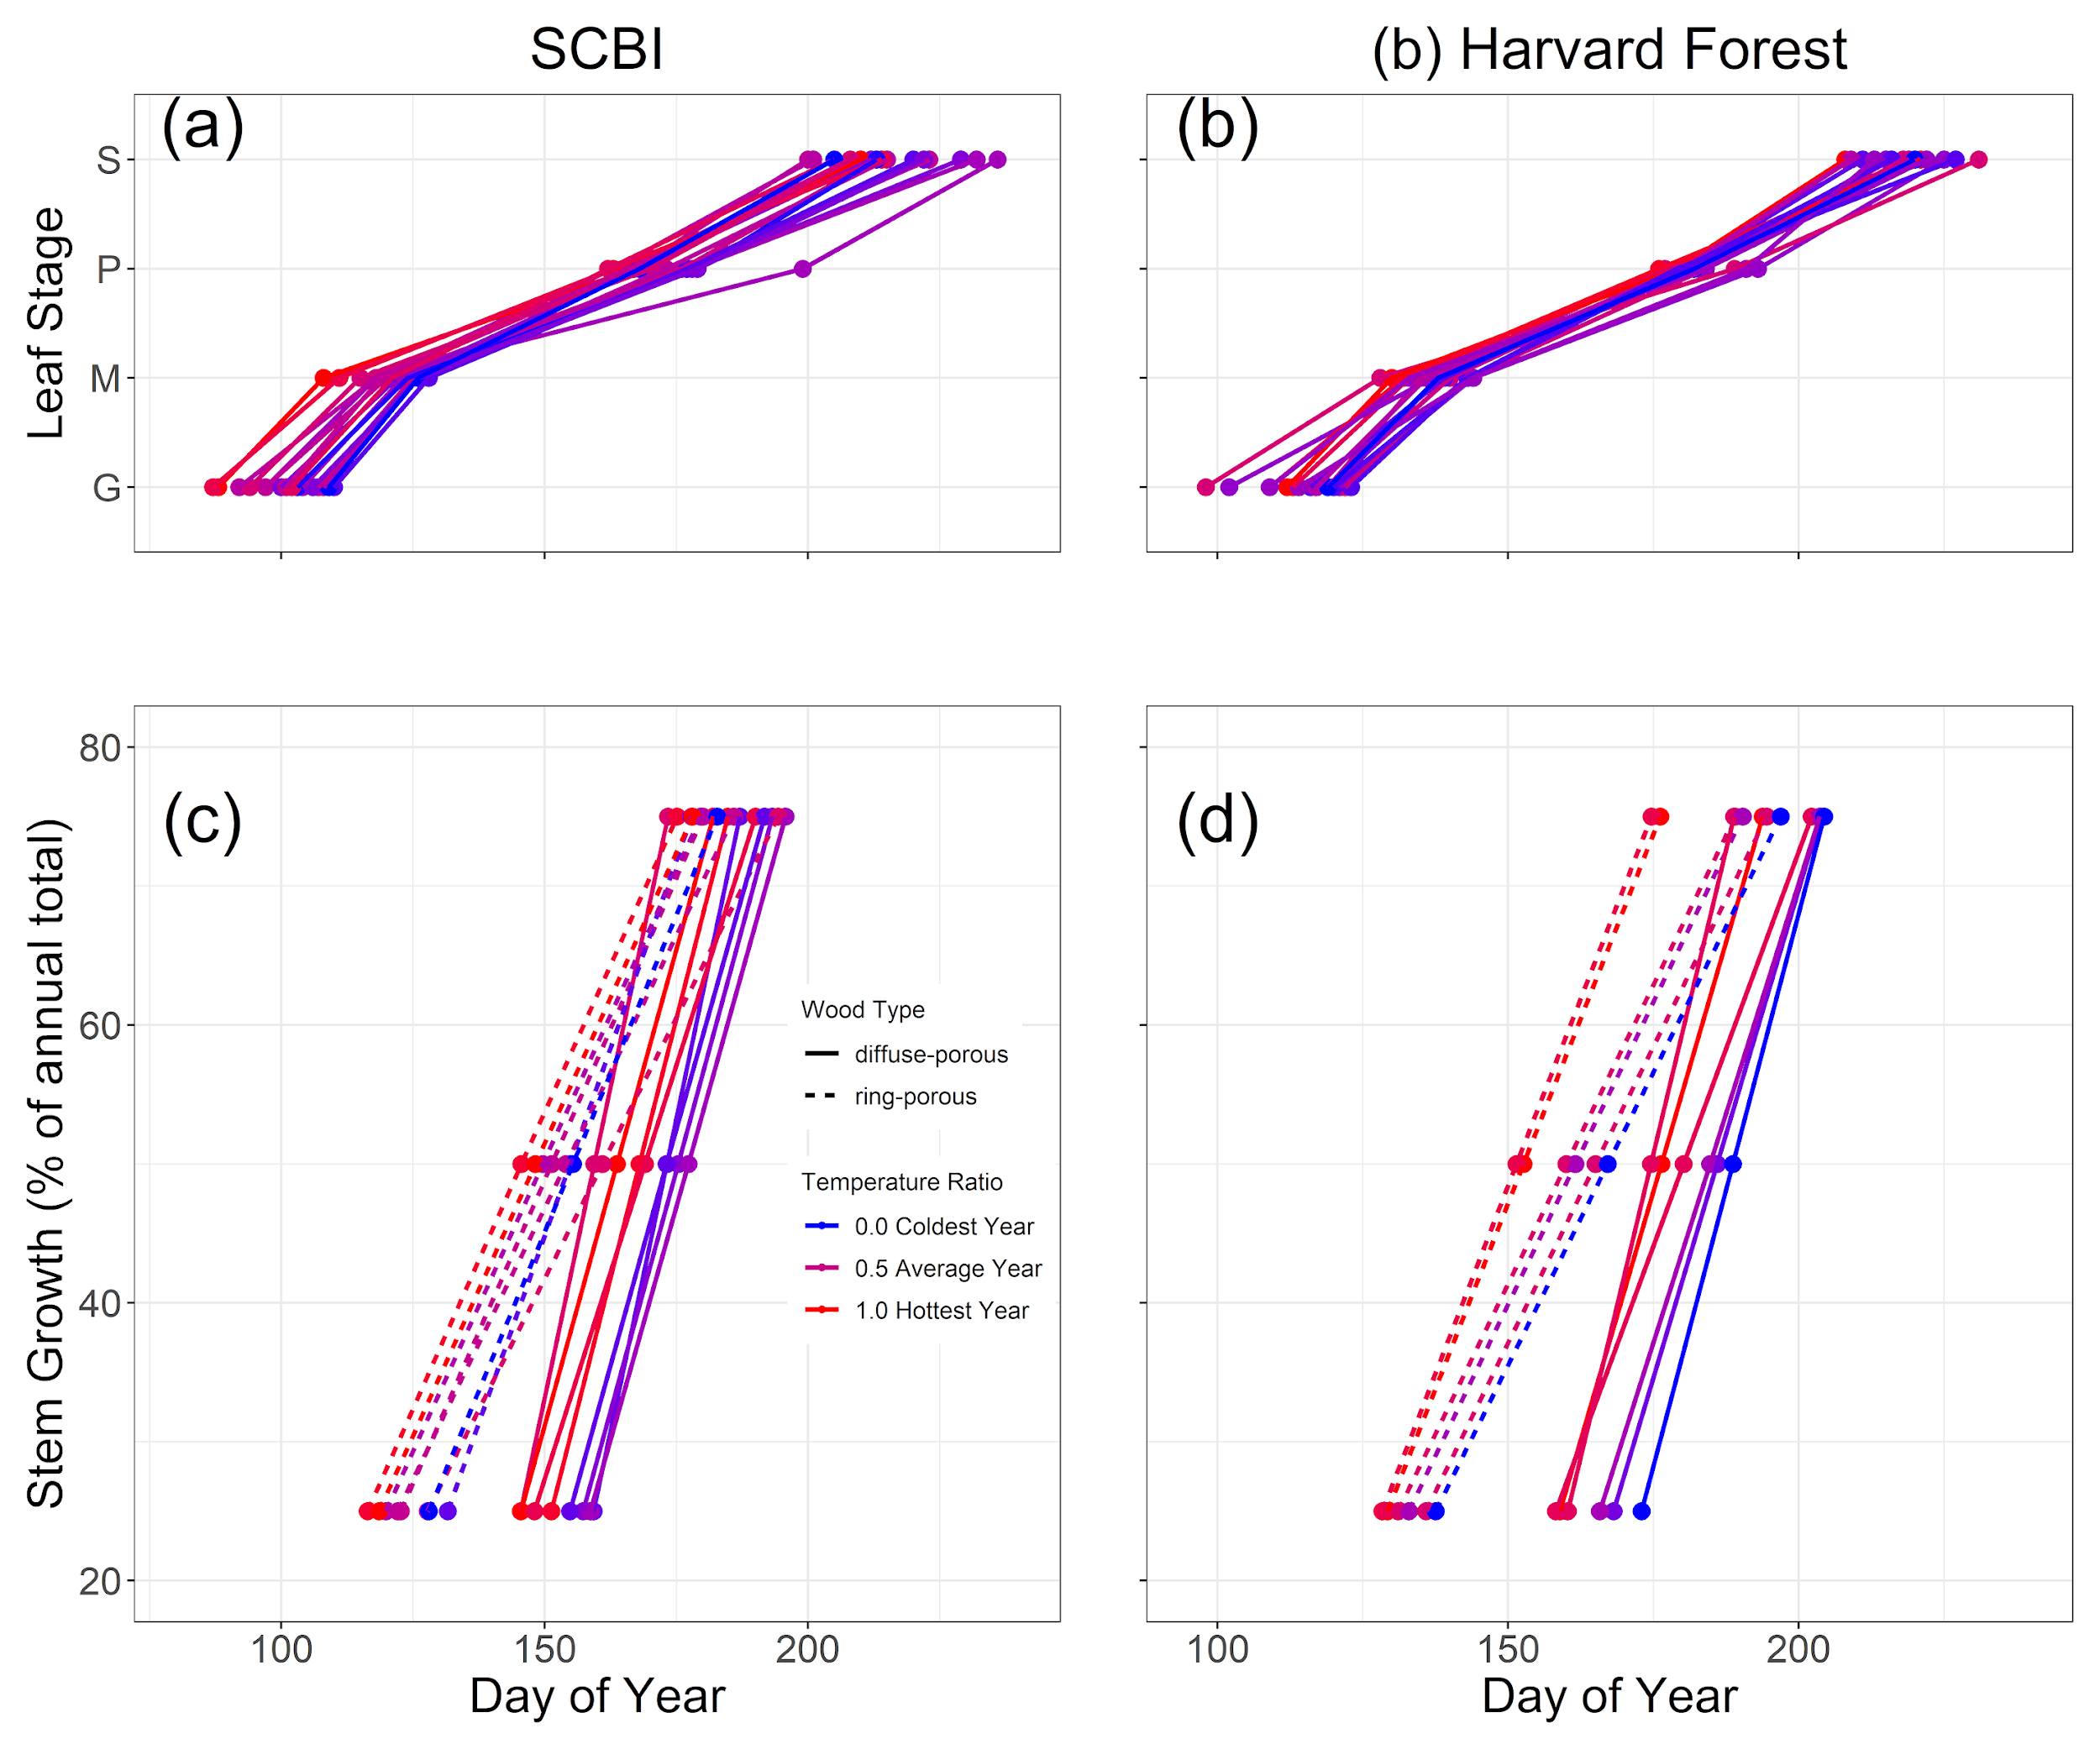

***Figure 2 | Leaf (a,b) and stem growth (c,d) phenology at the Smithsonian Conservation Biology Institute (a,c) and Harvard Forest (b,d).*** *Panels (a-b) show ecosystem-level leaf phenology, obtained from the MODIS Global Vegetation Phenology product (2001-2018), where G = Greenup, M=Mid-greenup, P=peak, and S=Senescence (i.e., beginning of green-down). Panels (c-d) show the dates at which stem growth milestones were acheived, on average, for sampled populations of ring-porous and diffuse-porous trees at SCBI (2011-2020) and Harvard Forest (1998-2003). Mean temperature was calculated for each wood-type/site combination over the respective critical window, then turned into a ratio and assigned a color on a gradient where the coldest year in the sample is blue and the warmest is red. (****SHOULD WE COMBINE LEAF AND STEM PHENOLOGY ON A SINGLE PLOT WITH SEPARATE Y-AXES? (KAT thinks so)*** *See [GitHub Issue #50](https://github.com/EcoClimLab/growth_phenology/issues/50). )*

Both leaf phenology and stem growth were sensitive to spring temperatures (Figs. 2 -3). While the results described below were qualitatively consistent considering both maximum and minimum temperatures ( and , respectively) across a range of spring time windows (Extended Data Figures 3-7), we focused our analyses on the strongest relationships: responses to over the consecutive weekly time window between Jan. 1 and for which the correlation between and was strongest (henceforth, critical temperature window, CTW; Fig. 1). The strongest relationships, including but not limited to the CTW (Extended Data Table 2), occurred for time windows closing 5 weeks prior to (Extended Data Figure 3).

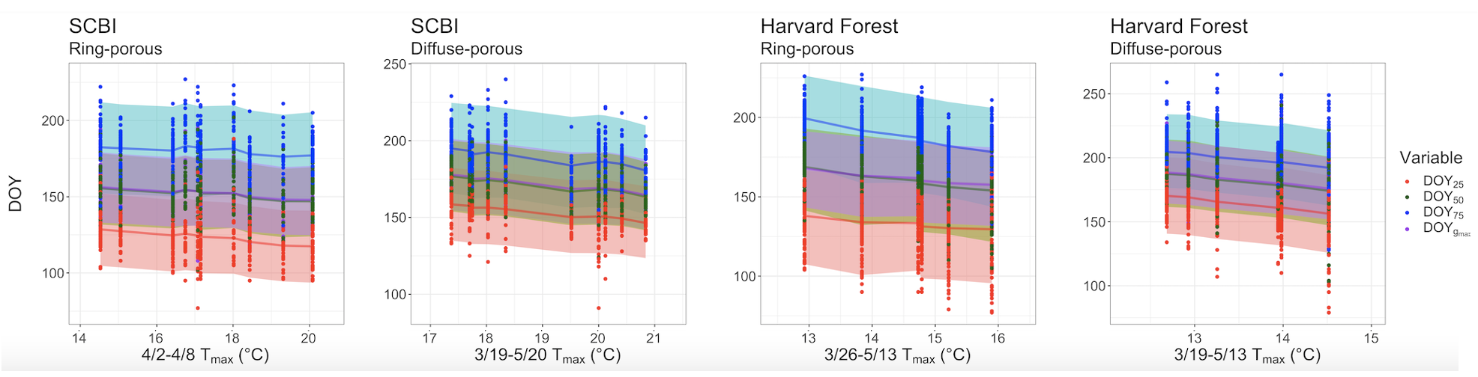

***Figure 3 | Response of the timing of stem growth phenology to spring temperatures.*** *The days of year on which 25%, 50% and 75% of annual growth were acheived (, , and , respectively) declinde significantly with mean during the critical temperature window (CTW). For each CTW , the posterior mean of the fitted day of year is represented by the solid line and 95% credible intervals are represented by bands. Relationsips for additional growth parameters (Fig. 1a) aare given in Extended Data Figure 4. (****DOYrmax will be dropped.*** *[GitHub Issue 23](https://github.com/EcoClimLab/growth_phenology/issues/23))*

For both ring- and diffuse- porous species at both sites, warmer in the CTW resulted in earlier achievement of growth milestones (Figs. 1-3). Consistent with findings from previous studies[REFS], at our focal sites the DOYs of leaf greenup and mid-greenup (measured at ecosystem level via remote sensing) advanced significantly with increasing during the CTW (p=## and ##, respectively). Specifically, [greenup DOY occurred 21 days earlier at SCBI and 7 days earlier at Harvard Forest when comparing the years with the warmest and coldest CTW](https://github.com/EcoClimLab/growth_phenology/issues/58) , and mid-greenup also advanced, but to a lesser extent (Fig. 2). Similarly, , , , and at both sites all decreased significantly with CTW , advancing [1-8 days per degree Celsius](https://github.com/EcoClimLab/growth_phenology/issues/58) during the CTW (Figs. 1- 3, 2; see also Extended Data Figures **4-6**).

Whereas the length of time between leaf greenup and senescence (*i.e.,* the day when greenness dropped below 90% of its peak) increased in years with warmer springs (Fig. 2), there was no consistent lengthening of the period of peak stem growth. Specifically, because – and not only – shifted earlier in years with warm springs, displayed mixed responses to spring temperatures (Fig. 1, Extended Data Figures **4-6**).

In contrast to the pronounced effects of on the timing of growth, its effects on and were less consistent and generally quite subtle (Figs. 1, 3). Neither maximum seasonal growth rate, , nor annual growth measured with dendrometer bands, , was consistently linked to early spring temperatures (Fig. 1, Extended Data Figures **4-6**). Specifically, , which occurred very close to (on ; Extended Data Table 2), displayed either no relationship to CTW (SCBI), or extremely small changes in opposite directions for ring- and diffuse- porous species (Harvard Forest), while displayed no relationship CTW (Extended Data Figure 4). Given the subtlety of these responses, a much longer record was needed to clarify what, if any, effect spring temperatures have on stem growth rates.

## Tree ring analysis

To understand how annual growth increments have responded to spring temperatures at the centennial scale, we analyzed tree-ring chronologies from our focal study sites (Extended Data Table 1) and across an additional 192 chronologies from 112 sites (Fig. 4, Extended Data Figure 1). For 12 species at SCBI and 3 species at Harvard Forest, ring width indices (RWI) rarely exhibited significant correlations to either or in the months corresponding to the CTWs identified here (Fig. 4, Extended Data Figure 7). Although correlations were rarely significant, there was a consistent pattern in responses to across all species at both sites: responses to were negative or neutral in all months from February to August, with the exception of one spring month at each site (April at SCBI, May at Harvard Forest) where growth displayed a positive or neutral responses to (Fig. 4). In these months, positive correlations to were statistically significant (at p=0.05) for one of nine ring-porous species at SCBI and one of two diffuse-porous species at each site. Starting in May at SCBI and June at Harvard Forest, negative correlations of RWI to were predominant, being statistically significant in at least one growing season month for all 12 species at SCBI and one of 3 species at Harvard Forest. Patterns in were fairly similar to those of , but weaker and more stochastic, with more (non-significant) correlations going in opposite directions (Extended Data Figure 7).

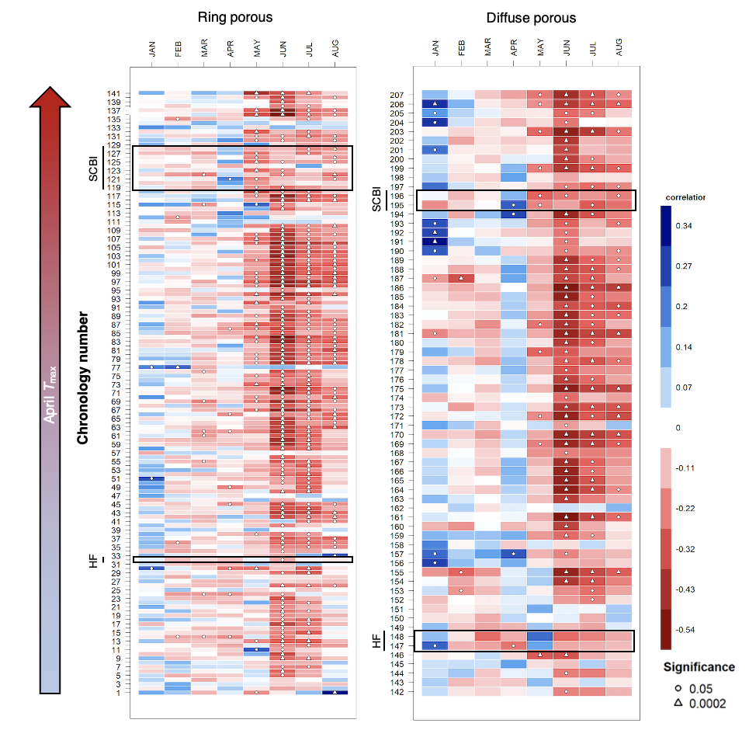

***Figure 4 | Sensitivity of annual growth, as derived from tree-rings, to monthly maximum temperatures, for 207 chronologies from 114 sites across eastern North America*** *(Extended Data Figure 1). Chronologies are grouped by xylem porosity and ordered by mean maximum April temperature. Chronology details are given in the Supplementary Information. (NOTE: Figure still needs some work.* ***COLOR SCALE IS A BIT OFF IN THIS COMPOSITE FIGURE (scales not identical across panels).*** *See [GitHub Issue #49](https://github.com/EcoClimLab/growth_phenology/issues/49).)*

The patterns observed at our focal sites were mirrored across an additional 192 chronologies from 112 sites (Fig. 4; Extended Data Figure 1)26. In total, our analysis included # species at sites distributed from XXX to XXX and spanning a ## C range in April T. Across all chronologies (focal sites included), RWI was significantly positively correlated with April for only #% of records: # of # ring-porous and # or # diffuse-porous species-site combinations. In contrast, RWI was frequently significantly negatively correlated with during peak growing season months (May-August), with significant correlations for #% and #% of species-site-month combinations for ring-porous and diffuse-porous species, respectively. Again, generally exerted less influence over annual growth than (Extended Data Figure 7), with few significant correlations between spring and RWI.

## Discussion

Together, our results demonstrate that warmer spring temperatures in the temperate deciduous forests of eastern North America advance the phenology of tree stem growth but have little effect on annual woody productivity (Figs. 1- 4). The observed advance in the timing of stem growth milestones under warmer springs is consistent with similar phenological advances observed for leaf development (Fig. 2)2 and NEE.2 *It would be interesting to compare the magnitude of these advances (days per degree C)* However, inconsistent with leaf phenology and NEE, we observed that the length of the period of most active stem growth does not increase under warmer springs. This suggests that stem growth, like leaf phenology16, may be sink-limited, such that an advance in the start of growth () accompanied by little change in growth rate () results in an earlier end to the season of rapid growth ().

The concept that stem growth is not enhanced under a longer growing season was supported by our tree-ring analysis, which showed that the effect of spring temperatures on annual growth is negligible for most species and locations, with at most modest influence for some species and locations (Fig. 4, Extended Data Figure 7)24,27. Rather, the primary effect of temperature on annual growth is a negative effect of during the peak growing season, which is primarily a signal of drought stress26. It is possible that an earlier start to the growing season may provide some buffer against drought later in the growing season28, potentially contributing to observed trends of declining drought sensitivity in the region24,29.

Our finding that interannual variation in woody growth is more strongly linked to conditions during the peak growing season than to growing season length aligns with parallel findings for NEE.9,10 However, there is a disconnect between the woody growth responses to spring temperatures observed here and parallel studies on NEE implying that annual C sequestration increases – at least modestly – with spring temperatures2 or with the length of the carbon uptake period9,10. We show that the extra C does not go into woody growth, raising the question of where this C goes. There are two main possibilities, which hold contrasting implications for the response of forest C balance to rising spring temperatures. First, C that is fixed in late summer or fall may be used for woody growth that is not apparent from diameter measurements in the current year: either used for thickening of cell walls, a process that lags behind stem expansion30, or saved within trees as non-structural carbohydrates and used towards growth the following year31,32. Tree-ring evidence from SCBI suggests that both processes may influence the climate sensitivity of annual woody growth, but that this dynamic is complex and unlikely to result in substantial additional growth in the following year.24 *we can easily test this: [GitHub issue 57](https://github.com/EcoClimLab/growth_phenology/issues/57))* Second, any additional C that is not rapidly respired may be allocated, likely in the following growing season, to plant functions other than stem growth, including respiration, reproduction, foliage, fine roots, or root exudates31. Most of this carbon would have a relatively low residence time in the ecosystem31, although a small fraction would be incorporated into soil organic carbon pools *with residence times rivaling that of wood [REFS]*. Notably, both of these involve lags of a year or more and would not be captured in interannual variation in NEE, implying that the long-term effect of lengthened growing season on NEE may not be captured in studies, including this one, that consider time frames of a year or less9,10. Studies examining long-term trends in growing season length and ecosystem C uptake2,6,7 – as opposed to their interannual variation – within or including the temperate deciduous biome showed increasing trends in both variables, suggesting that the C not allocated to current year growth may have a fairly long residence time within the ecosystem; however, the amount and fate of this carbon remains unknown.

Thus, a distinction between interannual variation and directional change may be critical when considering how directional climate change is likely to affect tree growth and ecosystem C dynamics. In addition to the existence of temporal lags between C uptake and release, which introduce a lot of uncertainty31, trees are likely to acclimate *to some extent* to warming temperatures[**REFS?**], and on even longer time scales, we are likely to see changes in forest composition and adaptation. If we look across spatial gradients where the latter have had time to play out, we see that longer growing seasons are correlated with greater tree growth[**REF?**], woody productivity33, and NEE.23 *Future research will be important to sorting this out.*

Despite remaining uncertainties, our findings contribute substantially to a broader picture of the influence of spring temperatures on forest ecosystem function. Warm spring temperatures result in earlier leaf-out (Fig. 2)1, an earlier start to net C sequestration2, and, as shown here, earlier initiation of stem growth (Figs. 1- 3). Yet, an earlier start to the growing season is not associated with a longer growing season or increased growth (Figs. 1, 4), presumably because stem diameter growth is curtailed by C sink limitation16 or drought24,26.

As climate change accelerates and spring temperatures become increasingly warmer, growing seasons will start earlier, but this is unlikely to provide the sustained increase in carbon sequestration that is anticipated in most models (Fig. 1)16. Because of this, temperate deciduous forests are likely to sequester less CO2 than most models suggest, implying that these models are underestimating future overall atmospheric CO2. (*see [GitHub issue 56 on representation in models](https://github.com/EcoClimLab/growth_phenology/issues/56)*)

# Methods

*We have not yet re-written the methods for Nature. Nature guidelines: Full methods, typically not exceeding 3000 words. May be subdivided by bold headings.*

## Study sites

Study sites included two temperate forests in the eastern United States, both part of the Forest Global Earth Observatory [ForestGEO; Anderson-Teixeira et al. 2015; Davies et al. 2021].

Our first study site was the forest dynamics plot located at the Smithsonian Conservation Biology Institute 5 km South of Front Royal, Virginia within the Blue Ridge Mountains (38.8935° N, 78.1454° W; elevation 273–338 m.a.s.l.). The forest here was established in the mid-19th century after conversion from agricultural fields. Dominate canopy species within the 25.6 ha forest plot include tulip poplar (*Liriodendron tulipifera*), oaks (*Quercus spp.*), hickories (*Carya spp.*). The climate is humid temperate, with a mean annual precipitation of 998 mm and temperatures averaging 1° C in January and 24° C in July ([helcoski_growing_2019]).

The second study site was Harvard Forest (42.5388° N, 72.1755° W, 340-368 m.a.s.l.), located near the central Massachusetts town of Petersham. Harvard forest is a secondary forest, having re-established following agricultural use *(time frame)* and signficant hurricane damage in *YEAR*. Dominate species within the 35 ha ForestGEO plot are eastern hemlock (*Tsuga canadensis*), oak (*Quercus spp.*) and maple (*Acer spp.*). The climate is temperate continental with a mean annual precipitation of 1120 mm and temperatures averaging -12° C in January and 19° C in July (D’Orangeville et al, ).

## Data collection and preparation

### Dendrometer bands

Metal dendrometer bands installed on a total of 463 trees within the SCBI and Harvard Forest ForestGEO plots (Extended Data Table 1). Bands were placed on dominant species, including two diffuse- and two ring-porous species at SCBI and eight diffuse- and three ring-porous species at Harvard Forest. Bands were measured with a digital caliper approximately every 1-2 weeks within the growing season from 2011-2020 at SCBI and 1998-2003 at Harvard Forest, respectively. The number of bands measured at each site fluctuated somewhat as trees were added or dropped (e.g., because of tree mortality) from the census. Across years, the number of bands sampled averaged *~135* (range: 99-145) at SCBI and *~717* (range: *700-755*) at Harvard Forest. In total, our analysis included 2459 tree-years (Extended Data Table 1).

Measurements were timed to begin before the beginning of spring growth and to continue through the cessation of growth in the fall. At SCBI, the median start date was 4/14, which was adjusted when early leaf-out of understory shrubs and herbs was observed, with the earliest start date being March 30, 2020. Measurements were continued through to fall leaf senescence, with the median end date being 10/17 and the latest end date was November 26, 2012. Timing of measurements at Harvard Forest was similar, with the median start date of 4/23 and median end date of 10/30. 1998 was an anomalous year where initial measurements were taken on 1/5, but not taken again until 4/15. The latest end date was November 11, 2002.

The dendrometer band data were manually cleaned by visual inspection before analysis. We screened for three classes of mistakes. First, when a weekly measurement was drastically different from previous week and following weeks, this was assumed to be a measurement error and the record was removed. Second, when measurements remained essentially unchanged for several readings, followed by a sudden jump followed by normal growth pattern, this was assumed to be a case where the band was stuck and then released. In these cases, the full annual record for the tree was removed. Third, there were cases where data were clearly wrong but with unknown causes. In cases where several measurements were an issue, they were simply removed. If there were no clear solutions to ‘fix’ the data, the entire year was removed from the analysis.

We fit the model of25 to define phenological dates and growth rates (Fig. 1). This five-parameter logistic model was fitted to dendrometer band data from each tree-year in R:

Here, and are lower and upper asymptotes of the model, corresponding to at the beginning and end of the year, respectively. are the modeled days of year (*i.e.*, julian days), is the day of year where the inflection point in growth rate occurs, *shapes the slope of the curve at the inflection point*, and is a tuning parameter controlling the slope of the curve toward the upper asymptote. *We note that the DOY on which maximum growth occurs, (Fig. 1) occurs on only when .* Using the optimized parameters for each tree-year, we then modeled throughout the year and extracted the intra-annual growth variables of interest (Fig. 1).

After fitting the25 model, we used a script to remove poorly fit models. Models were judged to be poorly fit if certain modeled growth characteristics fell outside of the acceptable range we determined. Modeled fits for tree-years were removed under five conditions: (1) single day growth rates were higher than 2 standard deviations away from the mean for each wood-type (SCBI = 2, HF = 34); (2) was standard deviations away from the mean for it’s xylem architecture group, year, and site (SCBI = 62, HF = 106); (3) tree-years with small or negligible total growth ( < 0.02 mm; SCBI = 0, HF = 66); (4) model fit predicted total yearly growth to take longer than 365 days, indicating poor model fit (SCBI = 181, HF = 199); and (5) models with unexplained sharp spikes in growth rate (SCBI = 0, HF = 3). At Harvard Forest the tag years removed through this method was proportional to the original sample size, indicating that no species or size class was disproportionately removed compared to others *(SI figure? data_cleaning_figure_hf in manuscript folder)*. At SCBI a higher proportion of RP trees were removed–the majority in step 4 *(data_cleaning_figure_scbi)*.

### 1.0.1 Leaf phenology

Leaf phenology data for the years 2001-2018 were extracted for SCBI and Harvard Forest from the MCD12Q2 V6 Land Cover Dynamics product (informally called the MODIS Global Vegetation Phenology product).34

description here: [https://developers.google.com/earth-engine/datasets/catalog/MODIS_006_MCD12Q2#description](https://developers.google.com/earth-engine/datasets/catalog/MODIS_006_MCD12Q2" \l "description)

### Tree rings

Dominant tree species were cored at both sites following sampling designs that covered a broad range of . We analyzed records for the dominant ring- and diffuse- porous species at each site (Extended Data Table 1), excluding species with other xylem architectures (*Juglans nigra* L. at SCBI, *Tsuga Canadensis* (L.) Carrière at Harvard Forest) At SCBI, cores were collected as described in.24 Briefly, cores were taken from living or recently dead trees 10 cm , including a randomly sampled subset of all dominant species within the ForestGEO plot [live trees in 2010-2011;]35 and trees found newly dead in annual tree mortality in 2016 and 2017.24 At Harvard Forest, …(*Neil can write this easily, or KAT probably has the info*) In total, we analyzed 926 cores from eleven species at SCBI and three species at Harvard Forest (Extended Data Table 1).

The tree-ring records from our focal sites were complemented with a much larger collection spanning 112 deciduous and mixed forest sites in Eastern North America26 (**OTHER REFS??**). Again, species were limited to broadleaf deciduous species with clearly defined xylem porosity (i.e., excluding semi-ring porous).

All cores were mounted, sanded, cross-dated, and measured using standard methodology. We standardized ring-width series from each core via ARSTAN using a 2/3rds spline, where is the number of years in the series.36,37 *The following italic text is self-plagarized from Helcoski and needs to be reworded:)* *The influence of outliers in all series was reduced using the adaptive power transformation, which also stabilises the variance over time.38 Next, each series was stabilised using either the average correlation between raw ring-width series (rbar) method or a 1/3rds spline method to adjust changes in variance as series replication decreased towards the earlier portion of each chronology.39 The 1/3rds spline method was chosen when replication in the inner portion of each chronology (c. the inner 30–50 yr of each record depending on full chronology length) dropped below three trees. Once that step was complete, a robust biweight mean chronology for each species was calculated from the ring-width indices.36 We chose to use residual chronologies because the autoregressive standardisation process in creating them removes much of the tree-level autocorrelation in growth and these chronologies would most likely contain the most conservative information on drivers of interannual growth.36* We defined chronology start year (Extended Data Table 1) as the year where subsample signal strength (SSS) passed a threshold of SSS = 0.8, or where 80% of the population signal was captured in the chronology.

### Climate

For the dendrometer band analysis, we used climate data from local weather stations. Daily maximum and minimum temperatures ( and , respectively) for SCBI were obtained from a meteorological tower adjacent to the SCBI ForestGEO plot, via the ForestGEO Climate Data Portal v1.0 [<https://forestgeo.github.io/Climate/>;].40 Daily temperature records for Harvard Forest were obtained from the Harvard Forest weather station (Boose & Gould, 2004; Boose, 2018). The R package climpact () was used to plot temperatures for visual inspection. Climpact also identifies readings that were greater than 3 standard deviations away from yearly means. These points were labeled as outliers and removed from the dataset. Gaps in the SCBI meteorological tower data were subsequently filled using temperature readings obtained from a National Center for Environmental Information (NCEI) weather station located in Front Royal, Virginia (<https://www.ncdc.noaa.gov/cdo-web/datasets/GHCND/stations/GHCND:USC00443229/detail>). (*how were gaps filled for Harvard? Or was the record good?*)

For the tree-ring analysis, we obtained monthly and data for 1901-2019 from CRU v.4.04,41 again via the ForestGEO Climate Data Portal v1.0.40

## 1.1 Analyses

### Determining critical temperature windows

The period where the phenology milestone(s) were most affected by changes in early spring temperature was determined using the R package *climwin*.42 This package tests the correlation between one or more climate variables and a biological variable over all consecutive time windows within a specified time-frame, reporting correlation and of each window. Here, we tested for correlation between temperature (, ) and over the time window from January 1 to the mean for the species group and site (Extended Data Table 2). *The critical time window is determined based on the subset of models that fall within the 95% confidence set.* Here, we focused on defining critical temperature windows for , as opposed to other growth phenology parameters (Figure 1), because we were interested in the influence of temperature on the initiation of woody growth. We note that other growth parameters would be controlled by different critical temperature windows; for example, at SCBI responds most strongly to May-July climate.24 Determining the climate variables that most strongly control all parameters is beyond the scope of this analysis.

### Hypothesis testing

(*This section needs work/ more detail.*)

Correlation between these variables and spring temperatures were assessed using a linear mixed model in a hierarchical Bayesian framework.

Mixed effects models were used to test the response of growth phenology variables (, , , , , and ) to fixed effects of xylem porosity and mean temperature (, ) during the critical temperature window selected by *climwin*, along with random effects of species and tree. We ran separate models for each species group at each site, and for the response of all growth phenology variables to and . Models were run using the LME4 package in R.43

This mixed-effect model was run within a hierarchical Bayesian framework and fit using the rstanarm R interface to the Stan programming language.**rstanarm_2020?** In all cases unless otherwise specified, all prior distributions are set to be the weakly informative defaults.

# Acknowledgements

people: (everyone who helped collect data– see list on GitHub), Jess Shue (data) Funding: ForestGEO

# Author Contributions

# Additional Information

**Supplementary Information** is available for this paper.

Correspondence and requests for materials should be addressed to Kristina Anderson-Teixeira ([teixeirak@si.edu](mailto:teixeirak@si.edu)).

# References

1. Jeong, S.-J., Ho, C.-H., Gim, H.-J. & Brown, M. E. Phenology shifts at start vs. End of growing season in temperate vegetation over the Northern Hemisphere for the period 1982. *Global Change Biology* **17**, 2385–2399 (2011).

2. Keenan, T. F. *et al.* Net carbon uptake has increased through warming-induced changes in temperate forest phenology. *Nature Climate Change* **4**, 598–604 (2014).

3. Menzel, A. & Fabian, P. Growing season extended in Europe. *Nature* **397**, 659–659 (1999).

4. Menzel, A. *et al.* European phenological response to climate change matches the warming pattern. *Global Change Biology* **12**, 1969–1976 (2006).

5. Ibáñez, I. *et al.* Forecasting phenology under global warming. *Philosophical Transactions of the Royal Society B: Biological Sciences* **365**, 3247–3260 (2010).

6. Keeling, C. D., Chin, J. F. S. & Whorf, T. P. Increased activity of northern vegetation inferred from atmospheric CO 2 measurements. *Nature* **382**, 146–149 (1996).

7. Dragoni, D. *et al.* Evidence of increased net ecosystem productivity associated with a longer vegetated season in a deciduous forest in south-central Indiana, USA. *Global Change Biology* **17**, 886–897 (2011).

8. Crabbe, R. A. *et al.* Extreme warm temperatures alter forest phenology and productivity in Europe. *Science of The Total Environment* **563-564**, 486–495 (2016).

9. Zhou, S. *et al.* Explaining inter-annual variability of gross primary productivity from plant phenology and physiology. *Agricultural and Forest Meteorology* **226-227**, 246–256 (2016).

10. Fu, Z. *et al.* Maximum carbon uptake rate dominates the interannual variability of global net ecosystem exchange. *Global Change Biology* **25**, 3381–3394 (2019).

11. Anderson-Teixeira, K. J. *et al.* Carbon cycling in mature and regrowth forests globally. *Environmental Research Letters* (2021) doi:[10.1088/1748-9326/abed01](https://doi.org/10.1088/1748-9326/abed01).

12. Xue, B.-L. *et al.* Global patterns of woody residence time and its influence on model simulation of aboveground biomass. *Global Biogeochemical Cycles* **31**, 821–835 (2017).

13. Russell, M. B. *et al.* Residence Times and Decay Rates of Downed Woody Debris Biomass/Carbon in Eastern US Forests. *Ecosystems* **17**, 765–777 (2014).

14. Profft, I., Mund, M., Weber, G.-E., Weller, E. & Schulze, E.-D. Forest management and carbon sequestration in wood products. *European Journal of Forest Research* **128**, 399–413 (2009).

15. Zohner, C. M. & Renner, S. S. Ongoing seasonally uneven climate warming leads to earlier autumn growth cessation in deciduous trees. *Oecologia* **189**, 549–561 (2019).

16. Zani, D., Crowther, T. W., Mo, L., Renner, S. S. & Zohner, C. M. Increased growing-season productivity drives earlier autumn leaf senescence in temperate trees. 7 (2020).

17. Arora, V. K. *et al.* Carbonconcentration and carbonclimate feedbacks in CMIP6 models and their comparison to CMIP5 models. *Biogeosciences* **17**, 4173–4222 (2020).

18. Friedlingstein, P. *et al.* Global Carbon Budget 2020. *Earth System Science Data* **12**, 3269–3340 (2020).

19. Parmesan, C. & Yohe, G. A globally coherent fingerprint of climate change impacts across natural systems. *Nature* **421**, 37–42 (2003).

20. Friedl, M. A. *et al.* A tale of two springs: Using recent climate anomalies to characterize the sensitivity of temperate forest phenology to climate change. *Environmental Research Letters* **9**, 054006 (2014).

21. Keenan, T. F. & Richardson, A. D. The timing of autumn senescence is affected by the timing of spring phenology: Implications for predictive models. *Global Change Biology* **21**, 2634–2641 (2015).

22. Vitasse, Y., Porté, A. J., Kremer, A., Michalet, R. & Delzon, S. Responses of canopy duration to temperature changes in four temperate tree species: Relative contributions of spring and autumn leaf phenology. *Oecologia* **161**, 187–198 (2009).

23. Churkina, G., Schimel, D., Braswell, B. H. & Xiao, X. Spatial analysis of growing season length control over net ecosystem exchange. *Global Change Biology* **11**, 1777–1787 (2005).

24. Helcoski, R. *et al.* Growing season moisture drives interannual variation in woody productivity of a temperate deciduous forest. *New Phytologist* **223**, 1204–1216 (2019).

25. McMahon, S. M. & Parker, G. G. A general model of intra-annual tree growth using dendrometer bands. *Ecology and Evolution* **5**, 243–254 (2015).

26. D’Orangeville, L. *et al.* Drought timing and local climate determine the sensitivity of eastern temperate forests to drought. *Global Change Biology* **24**, 2339–2351 (2018).

27. Alexander, M. R. *et al.* The potential to strengthen temperature reconstructions in ecoregions with limited tree line using a multispecies approach. *Quaternary Research* **92**, 583–597 (2019).

28. Wolf, S. *et al.* Warm spring reduced carbon cycle impact of the 2012 US summer drought. *Proceedings of the National Academy of Sciences* **113**, 5880–5885 (2016).

29. Maxwell, J. T., Harley, G. L. & Robeson, S. M. On the declining relationship between tree growth and climate in the Midwest United States: The fading drought signal. *Climatic Change* **138**, 127–142 (2016).

30. Cuny, H. E. *et al.* Woody biomass production lags stem-girth increase by over one month in coniferous forests. *Nature Plants* **1**, 15160 (2015).

31. Trumbore, S., Gaudinski, J. B., Hanson, P. J. & Southon, J. R. Quantifying ecosystem-atmosphere carbon exchange with a 14C label. *Eos, Transactions American Geophysical Union* **83**, 265–268 (2002).

32. Richardson, A. D. *et al.* Seasonal dynamics and age of stemwood nonstructural carbohydrates in temperate forest trees. *New Phytologist* **197**, 850–861 (2013).

33. Banbury Morgan, R. *et al.* Global patterns of forest autotrophic carbon fluxes. *Global Change Biology* gcb.15574 (2021) doi:[10.1111/gcb.15574](https://doi.org/10.1111/gcb.15574).

34. Friedl, M., Gray, J. & Sulla-Menashe, D. MCD12Q2 MODIS/Terra+Aqua Land Cover Dynamics Yearly L3 Global 500m SIN Grid V006. (2019) doi:[10.5067/MODIS/MCD12Q2.006](https://doi.org/10.5067/MODIS/MCD12Q2.006).

35. Bourg, N. A., McShea, W. J., Thompson, J. R., McGarvey, J. C. & Shen, X. Initial census, woody seedling, seed rain, and stand structure data for the SCBI SIGEO Large Forest Dynamics Plot: *Ecological Archives* E094-195. *Ecology* **94**, 2111–2112 (2013).

36. Cook, E. R. A Time Series Analysis Approach to Tree Ring Standardization. vol. PhD (University of Arizona, 1985).

37. *Methods of Dendrochronology: Applications in the Environmental Sciences*. (Springer Netherlands, 1990). doi:[10.1007/978-94-015-7879-0](https://doi.org/10.1007/978-94-015-7879-0).

38. Cook, E. R. & Peters, K. Calculating unbiased tree-ring indices for the study of climatic and environmental change. *The Holocene* **7**, 361–370 (1997).

39. Jones, P. D., Osborn, T. J. & Briffa, K. R. Estimating sampling errors in large-scale temperature averages. *Journal of Climate* **10**, 2548–2568 (1997).

40. Anderson-Teixeira, K. *et al.* Forestgeo/Climate: Initial release. (2020) doi:[10.5281/ZENODO.4041609](https://doi.org/10.5281/ZENODO.4041609).

41. Harris, I., Osborn, T. J., Jones, P. & Lister, D. Version 4 of the CRU TS monthly high-resolution gridded multivariate climate dataset. *Scientific Data* **7**, (2020).

42. van de Pol, M. *et al.* Identifying the best climatic predictors in ecology and evolution. *Methods in Ecology and Evolution* **7**, 1246–1257 (2016).

43. Bates, D., Mächler, M., Bolker, B. & Walker, S. Fitting Linear Mixed-Effects Models Using **Lme4**. *Journal of Statistical Software* **67**, (2015).